Earthquakes & Earth’s Interior
Earthquakes
P-Waves & S-Waves
Shadow Zones
Tsunamis
Volcanoes
Hot Spots
- What are geologic hazards?

- Geologic hazard: ______________________ that can place ______________________ of injury, loss of life, or property damage.

- What are earthquakes? Where do earthquakes occur?

- Earthquake: ______________________________ caused by the rapid movement of rocks in the crust

  - Causes: ________________________ in the rocks beneath the Earth's surface

  - Locations: near ______________________ such as along the Pacific “Ring of Fire”

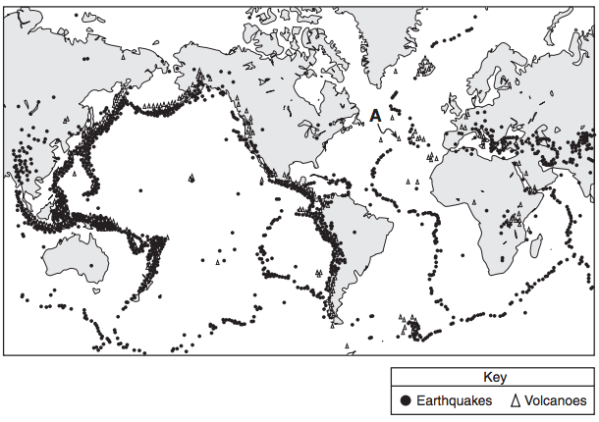
- Where do earthquakes originate?

- ____________: underground location where the _________________________________

- Epicenter: point on Earth’s surface ____________________________________________

  - Earthquakes are felt ____________________________________________
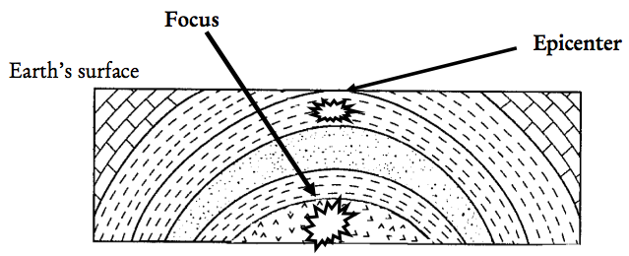

- How do scientists detect earthquakes?

- _________________: _____________________________ that travel outward from the focus of the earthquake.

Two Types of Waves
Wave Direction | Direction wave is moving  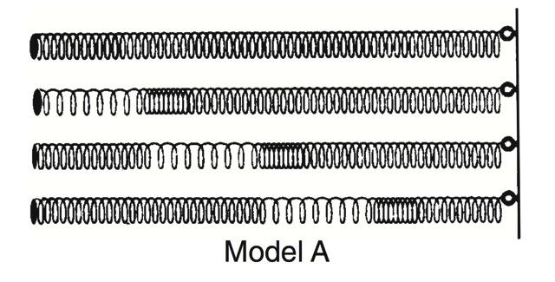 | __________________ being shaken  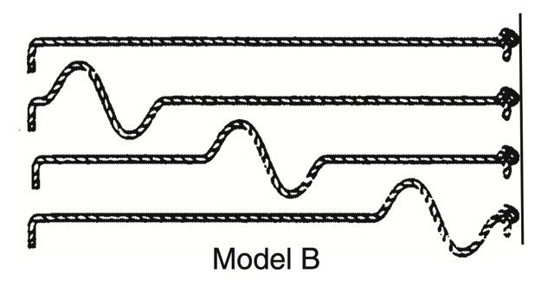
Velocity | ____________ waves (______ first) | ___________waves (____________)
Medium | Can travel through ______________ | Can only travel through _________ (absorbed by liquids)

- Earthquake Detection: Scientists use a _____________to detect movement of tectonic plate:
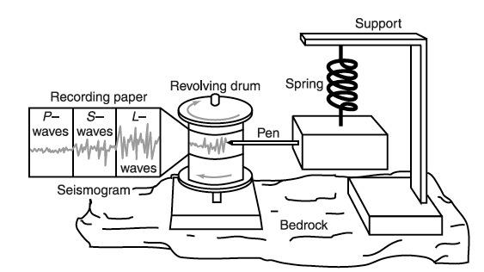

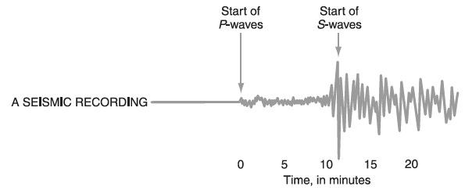
- How strong are earthquakes?

- _______________: the _______________ of and energy of an earthquake

- Earthquake magnitude scales:

  - Richter scale: ______________ of strength based on seismic waves (___________)

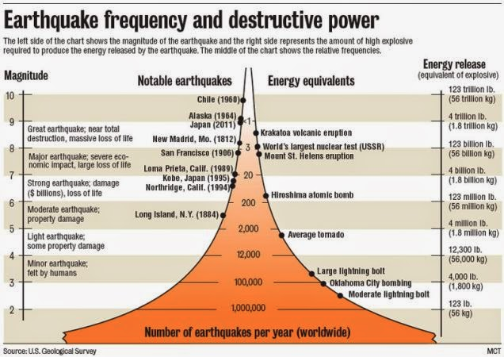

- Modified Mercalli scale: measure of __________________________________________
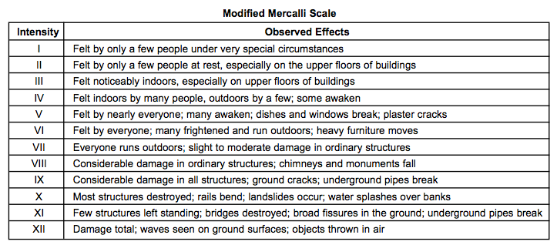
- How do we prepare for potential earthquakes?

- Earthquakes are __________________, but most often _______________________________.

- Earthquake Potential Damage:

  - Most human injury & death from earthquakes is due to _________________________.

  - Buildings in ____________________________________________. Structures can collapse, tilt, or sink into ground.

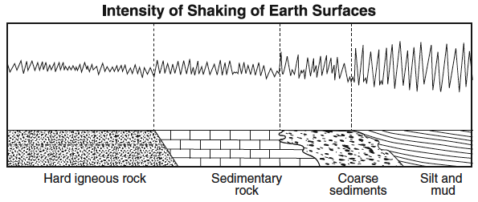

- ____________________________: “Drop, cover, & hold”, evacuation plans, supplies of food and water, first aid kit, building earthquake resistant structures, battery-operated radio

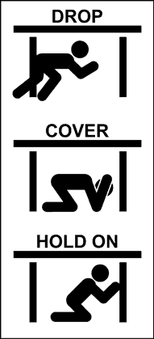
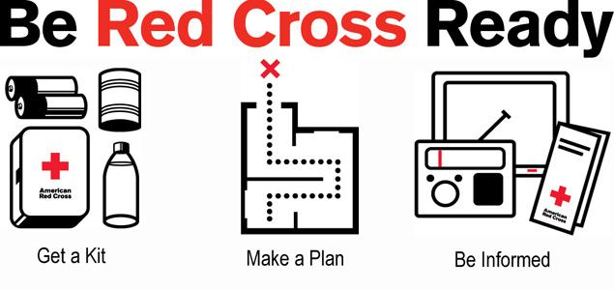
- Checkpoint – Earthquakes: The passage provides some information about the sediments under Portland, Oregon, and the map shows where Portland is located.

Bad seismic combination under Portland: Earthquake faults and jiggly sediment

Using a technique called seismic profiling, researchers have found evidence of ancient earthquake faults under Portland, Oregon. The faults may still be active, a USGS [United States Geological Survey] seismologist will announce tomorrow.
The research also turned up a 250-foot deep layer of silt and mud, deep under the city, which may have been caused by a catastrophic ice dam break some 15,000 years ago.
The two findings could together mean bad news, as soft sediment is known to amplify ground shaking during strong earthquakes. In the 1989 San Francisco earthquake, much of the damage to buildings was caused by liquefaction, a shaking and sinking of sandy, water-saturated soil along waterways. . . .
— Robert Roy Britt
excerpted from
“Bad sesimic combination under Portland:
Earthquake faults and jiggly sediment”
explorezone.com 05/03/99
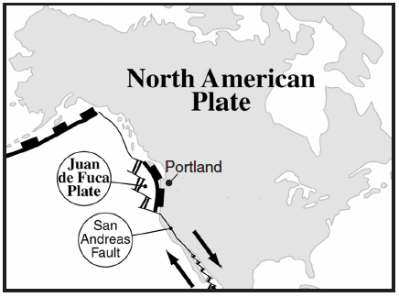

- Explain why Portland is likely to experience a major earthquake.

- Why is the presence of a layer of silt and mud deep under the city a danger to Portland?

- Describe one precaution that can be taken to prevent or reduce property damage in preparation for a future earthquake in Portland.
- How do seismic waves indicate distance from an epicenter?

- The closer a seismic station is to an epicenter:

- Checkpoint - Seismogram: Determine the relative distance of each seismic station to the epicenter based on the seismograms for each station shown below.

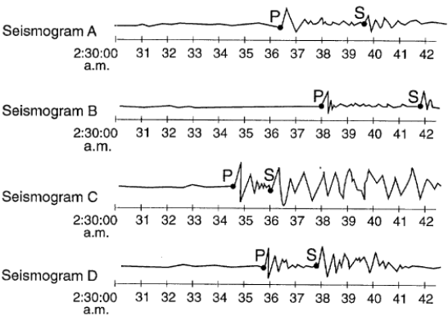

- Where can seismic waves be detected on Earth?

- As P-waves and S-waves pass through different layers within Earth’s interior, they are refracted due to differences in ____________.

- Some areas on Earth’s surface only receive P-waves, because S-waves _______________
_____________________________________________________

- ________________: Some areas on Earth’s surface will not receive seismic waves because S-waves are absorbed by the outer core and P-waves are refracted by the outer core.

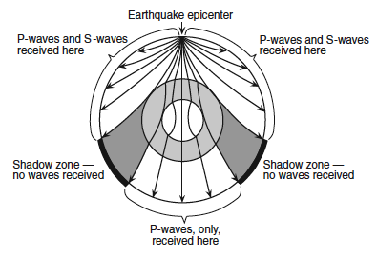
- Checkpoint: The cross section represents the pattern of seismic wave movement away from an earthquake. Point W represents a location at the boundary between two layers of Earth’s interior. Points X, Y, and Z represent seismic stations on Earth’s surface.
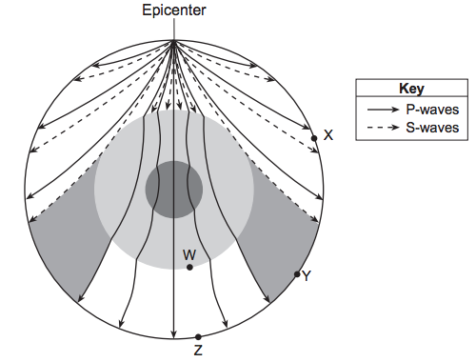
- Which data best describe the depth below Earth’s surface and the density of Earth’s interior at location W?
(1) Depth: 600 km
Density: changes from 3.4 g/cm³ to 5.6 g/cm³
(2) Depth: 1000 km
Density: averages 4.5 g/cm³
(3) Depth: 2900 km
Density: changes from 5.6 g/cm³ to 9.9 g/cm³
(4) Depth: 5100 km
Density: averages 11.1 g/cm³

- Which statement best explains why no S-waves were received directly from this earthquake at some seismic stations?
(1) An interior Earth layer absorbs S-waves. (3) S-waves travel slower than P-waves.
(2) Earth’s mantle reflects S-waves. (4) S-waves travel only on Earth’s surface

- The diagram below represents the seismograms of this earthquake recorded at seismic stations X, Y, and Z.
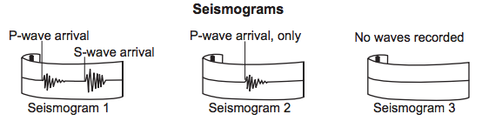
Which table best matches each seismic station with its likely seismogram?
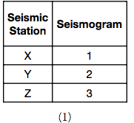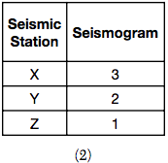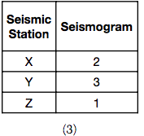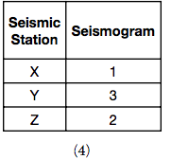
- What are tsunamis?

- _______________: ______________________________________. Can cause severe destruction in coastal areas

  - Tsunami Preparation: ____________________________________________
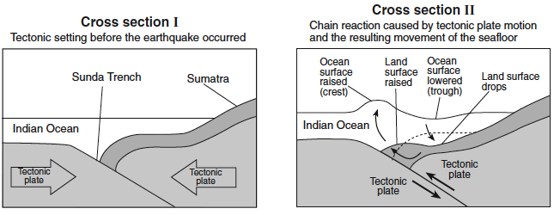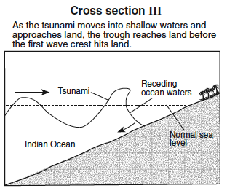

The map shows the travel time of seismic sea waves (tsunamis) from locations around the Pacific Ocean to the Hawaiian Islands. For example, an earthquake at any location on the line labeled “6 h” could produce a tsunami that would arrive in Honolulu, Hawaii, 6 hours.
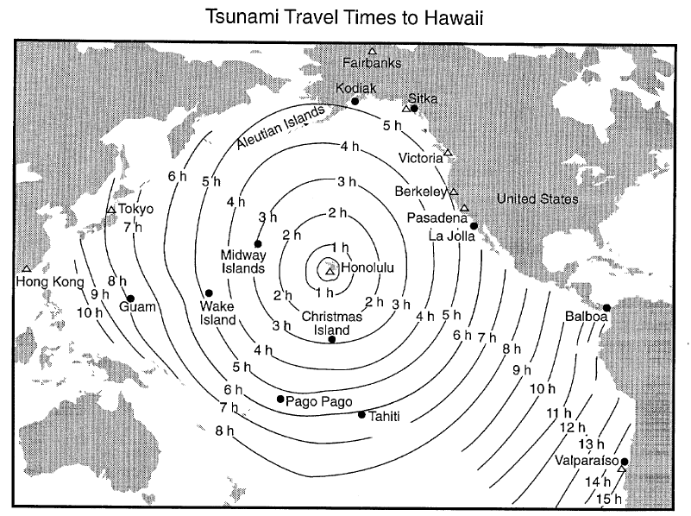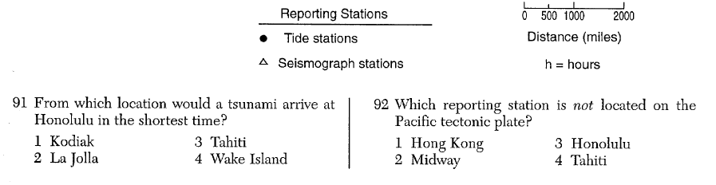
- What is a volcano?

- _____________: a vent in Earth through which molten magma erupts, producing a mountain of the material

  - Many volcanoes form ____________________________.

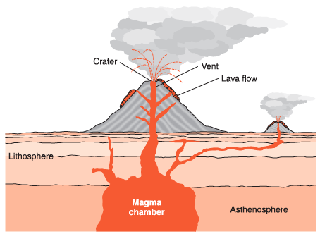

- How do we know if a volcano is going to erupt?

- Volcanic eruptions are ________________, but some warning signs of an imminent eruption include ________________ ___and __________________________near a volcano.

- What are the hazards associated with a volcano?

- Volcanic ashfall (Review ESRT page 14 – Atmosphere)

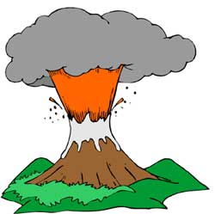
- Mudflows from melted snow and flash flooding

- Wildland fires from burned trees

- Earthquakes

- Tsunamis (if volcano is in/near ocean)

- What should you do to remain safe during a volcanic eruption?

- ________________if you live in a hazardous area

- Have an ________________________________________________ with your family

- Cover mouth, nose, eyes, and skin covered to avoid irritation from volcanic ash.

- What are the benefits of volcanoes?

- ______________________ (Hawaii) and new rocks (Review ESRT page 6 – Igneous Rocks)

- Weathered volcanic ash makes ____________________

- Sources of ________________activity

- Create ______________________ (pumice used as abrasive; basalt used in crushed stones)

- Checkpoint – Eruption at Mount St. Helens

On May 18, 1980, a cataclysmic eruption occurred at Mount St. Helens. It was one of the most destructive volcanic events ever recorded in the history of the United States. Mount St. Helens is a 2549-meter high stratovolcano that is located in Skamania County, Washington. It is the most active volcano in the Cascade Range, which runs along the northwestern coast of North America. The Cascade Range is part of the Pacific Ring of Fire.

On the morning of May 18, 1980, a 5.1 magnitude earthquake struck and the bulging northern flank of the volcano collapsed along with the summit. The collapse allowed hot pressurized magma in the volcano to erupt and large amounts of material were ejected over the course of the next nine hours. The ash plume from the eruption reached a towering height of 24 kilometers, and thick ash blanketed the surrounding region.

The dense forest that covered the slopes of the volcano was reduced to ash inside an area known as the inner blast zone, which extended about 10 kilometers (6.2 miles) from the summit. Trees farther away from the inner blast zone were also damaged by the searing heat. Lahars, which are a type of volcanic landslide, formed rapidly from the melting ice, snow and muddy debris released during the collapse of the volcano’s flank and summit. The lahars caused extensive damage to homes, roads and bridges in nearby communities outside of the inner blast zone.

Fifty-seven people including volcanologist David A. Johnston and photojournalist Reid Blackburn lost their lives during the May 18, 1980 eruption at Mount St. Helens.

The movement of the ash at a height of 1.5 kilometers above sea level is shown as a shaded path on the map below. The times marked on the path indicate the length of time the leading edge of the ash cloud took to travel from Mount St. Helens to each location.
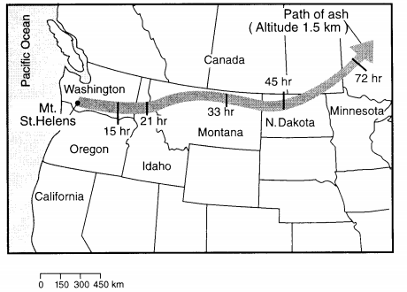
- Calculate the average rate of movement of the volcanic ash for the first 15 hours. Show work.

- State the name of the layer of Earth’s atmosphere is which the highest ash in the plume reached.

- The Mount St. Helens volcano is composed mostly of andesite rock. What are the three most common minerals at this location?

- An Earth science class is preparing a booklet on emergency preparedness. State one safety measure that should be taken to minimize danger from a volcano.

- How do volcanoes form at locations that are not plate boundaries?

- _______________: There are locations on earth, away from plate boundaries, where volcanic activity occurs.

  - Magma rises from the mantle and forces its way through the lithosphere, forming a chain of volcanoes.

  - As each old volcano moves off the hot spot it becomes ________and _____________ forms over the plume. In this way long chains of volcanoes form. The Hawaiian Islands are part of such a chain.

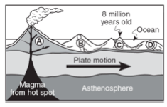

- Checkpoint – The Hawaiian Hot Spot: The block diagram below shows the bedrock age and the present location of the Hawaiian Island chain. These volcanic islands may have formed as the plate moved over a mantle hot spot.

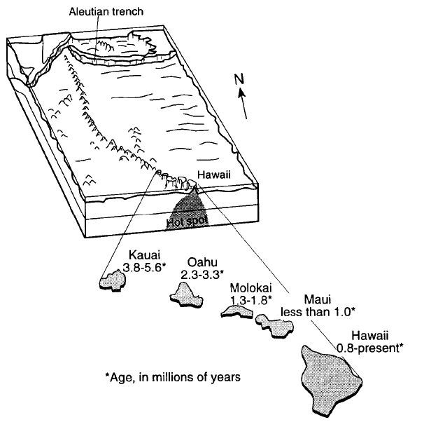

- Which island is the oldest?

- Which island is the youngest?

- Which plate is the Hawaiian Hot Spot located on?

- In which direction is the plate probably moving toward?

- Make an inference on why the island of Hawaii is larger than any of the other islands.

- Another island is forming in the same area. Looking at the chain of existing islands, infer where this new island is forming?

